**Week 6 – Hands-on : React**

Exercise 1: Creating a react application

1. First we open ‘Command prompt’ and type in the command to create a new react app named ‘myfirstreact’

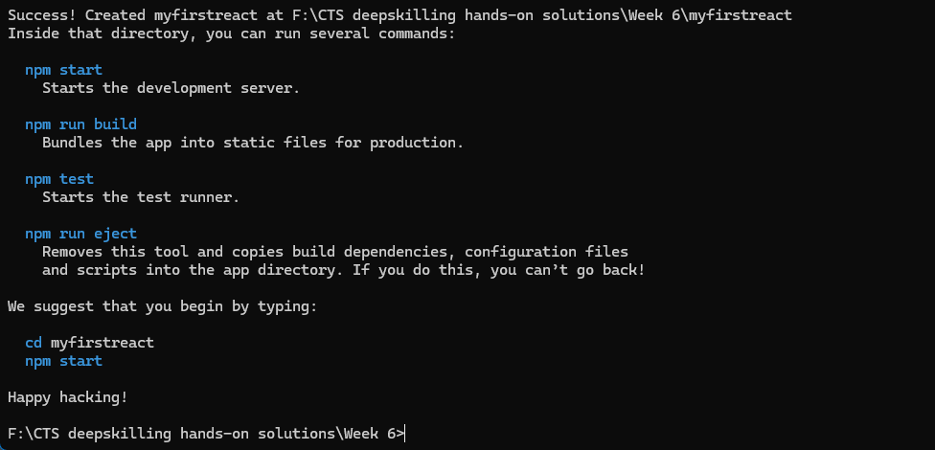

after all packages are installed we get this success message.

2. Now we open the project folder in Visual Studio Code

3. In src/App.js we replace the content with

import React from 'react';

function App(){

  return(

    <div>

      <h1>Welcome to the first session of my React application</h1>

    </div>

  );

}

export default App;

4. Now we open a terminal in the same path as our project folder and run the command “npm start”

**OUTPUT (Console):**

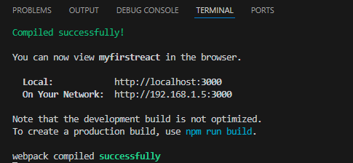

**OUTPUT (Browser):**

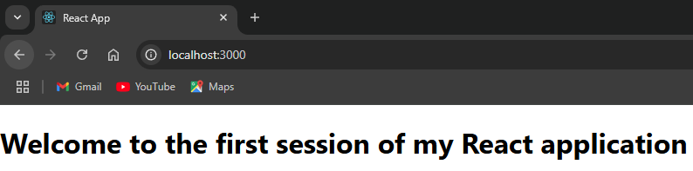

Exercise 2: Creating a react app for Student Management Portal

1. Open ‘Command prompt’ and type in the command to create a new react app named ‘student-app’

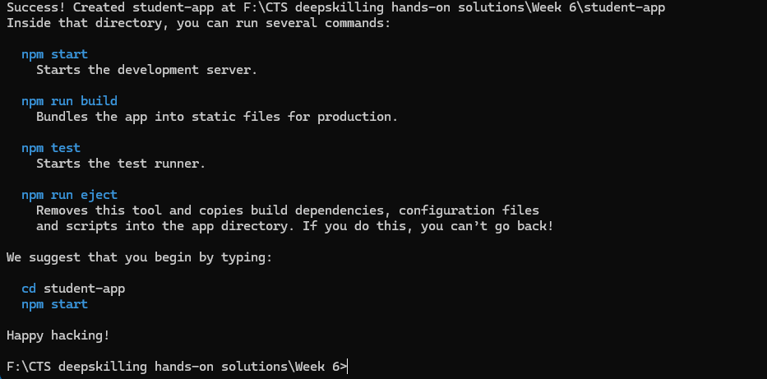

after all packages are installed we get this success message.

2. Now we open the project folder in Visual Studio Code

3. In src folder we create a new folder called ‘components’, inside which we create .js files called Home, Contact and About

Home.js

import React from 'react';

class Home extends React.Component{

    render(){

        return <h2>Welcome to home page of my Student Management portal</h2>;

    }

}

export default Home;

About.js

import React from 'react';

class About extends React.Component{

    render(){

        return <h2>Welcome to about page of my Student Management portal</h2>;

    }

}

export default About;

Contact.js

import React from 'react';

class Contact extends React.Component{

    render(){

        return <h2>Welcome to contact page of my Student Management Portal</h2>;

    }

}

export default Contact;

4. Now we modify the App.js file to import all the created class components and call it

import React from 'react';

import Home from './components/Home';

import Contact from './components/Contact';

import About from './components/About';

function App(){

  return(

    <div>

      <Home />

      <Contact />

      <About />

    </div>

  );

}

export default App;

**OUTPUT (Console):**

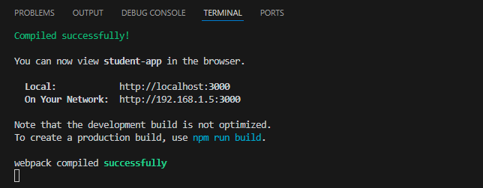

**OUTPUT(Browser):**

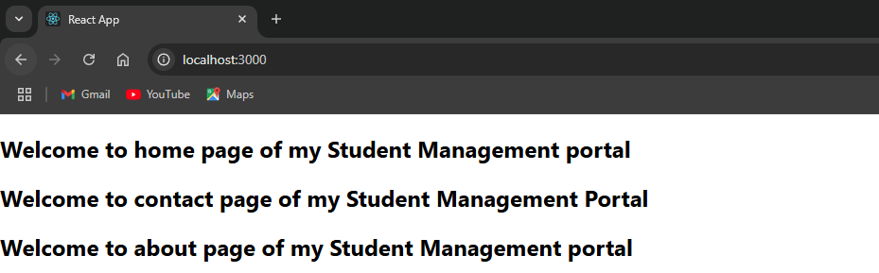

Exercise 3: Creating a score calculator app

1. Open ‘Command prompt’ and type in the command to create a new react app named ‘score-calculator-app’

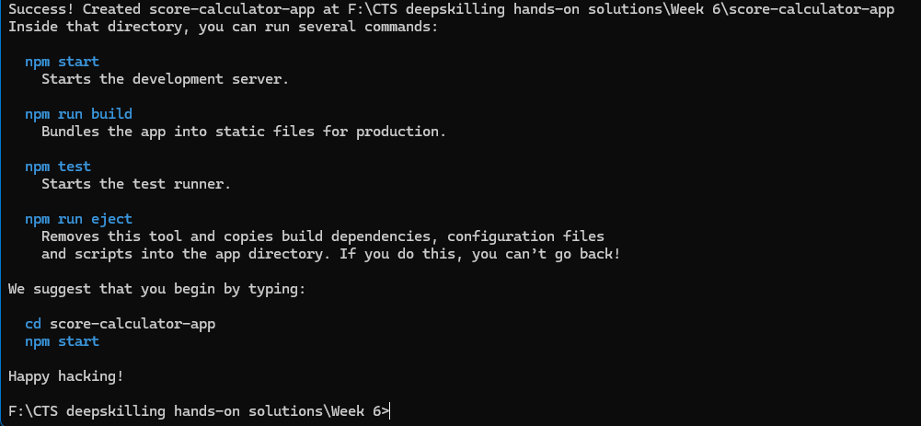

after all packages are installed we get this success message.

2. Now we open the project folder in Visual Studio Code

3. In src folder we create a new folder called ‘components’, inside which we create CalculatorScore.js

import React from 'react';

import '../stylesheets/mystyle.css';

function CalculateScore(props){

    const avg = props.total/props.subjects;

    return(

        <div className = "score-card">

            <h2>Student Score Calculator</h2>

            <p><strong>Name: </strong> {props.name}</p>

            <p><strong>School: </strong>{props.school}</p>

            <p><strong>Total: </strong>{props.total}</p>

            <p><strong>Subjects: </strong>{props.subjects}</p>

            <p><strong>Average: </strong>{avg}</p>

        </div>

    );

}

export default CalculateScore;

4. Create another folder inside src as Stylesheets inside that we create mystyle.css

.score-card {

  border: 2px solid #4CAF50;

  padding: 20px;

  margin: 20px auto;

  width: 400px;

  border-radius: 10px;

  background-color: #f9f9f9;

  font-family: Arial, sans-serif;

  box-shadow: 2px 2px 12px #aaa;

}

.score-card h2 {

  color: #4CAF50;

}

5. We modify the App.js as

import React from 'react';

import './App.css';

import CalculateScore from './components/CalculateScore';

function App(){

  return(

    <div className="App">

      <CalculateScore name = "John" school = "RPC" total={450} subjects={5} />

    </div>

  );

}

export default App;

**OUTPUT(Console):**

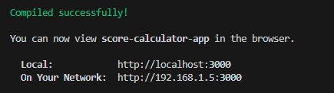

**OUTPUT(Browser):**

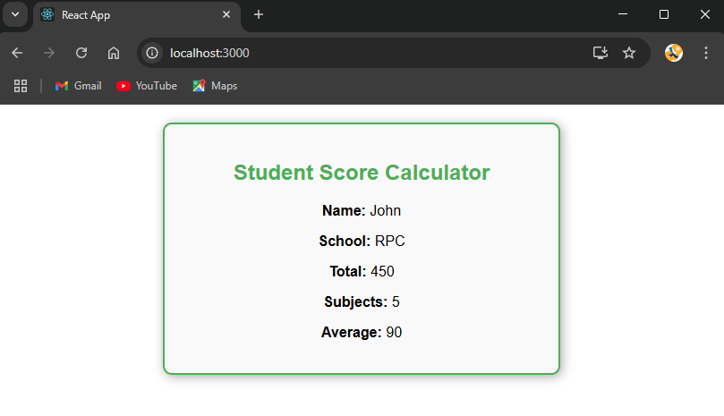

Exercise 4: Creating a blog app

1. Open ‘Command prompt’ and type in the command to create a new react app named ‘blog-app’

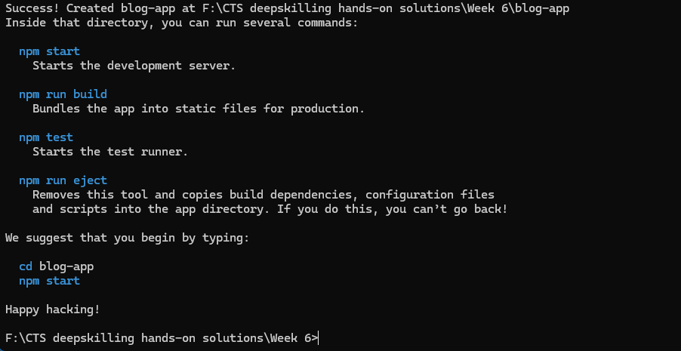

after all packages are installed we get this success message.

2. Now we open the project folder in Visual Studio Code

3. In src folder we create a new folder called ‘components’, inside which we create Blog.js

import React from "react";

class Blog extends React.Component {

  constructor(props) {

    super(props);

    this.state = {

      posts: [],

      error: null,

    };

  }

  componentDidMount() {

    this.loadPosts();

  }

  loadPosts() {

    fetch("https://jsonplaceholder.typicode.com/posts")

      .then((response) => {

        if (!response.ok) throw new Error("Network response error");

        return response.json();

      })

      .then((data) => {

        this.setState({ posts: data });

      })

      .catch((error) => {

        this.setState({ error });

      });

  }

  componentDidCatch(error, info) {

    alert(`An error occurred: ${error.message}`);

  }

  render() {

    if (this.state.error) {

      return <h2>Error loading posts!</h2>;

    }

    return (

      <div>

        <h1>Blog Posts</h1>

        <ul>

          {this.state.posts.map((post) => (

            <li key={post.id}>

              <strong>{post.title}</strong>

              <p>{post.body}</p>

            </li>

          ))}

        </ul>

      </div>

    );

  }

}

export default Blog;

4. We modify the App.js to load this component

import React from 'react';

import Blog from './components/Blog';

function App(){

  return(

    <div className="App">

      <Blog />

    </div>

  );

}

export default App;

**OUTPUT(Console):**

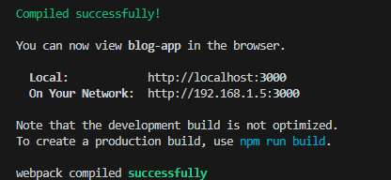

**OUTPUT(Browser):**

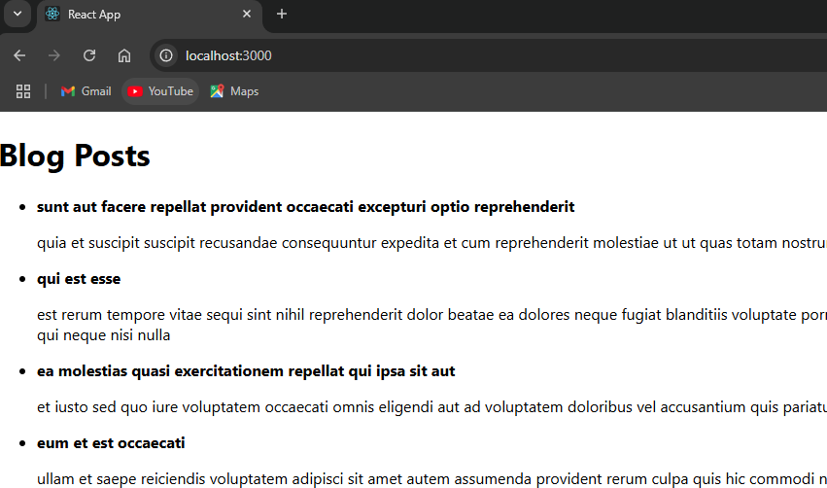

Exercise 5: Creating and styling cohort tracker

1. Since the hands-on document doesn’t contain the base app (Cohort tracker) we create a new cohort tracker app and then do the required styling to the react componenets.

2. Open ‘Command prompt’ and type in the command to create a new react app named ‘cohort-tracker’

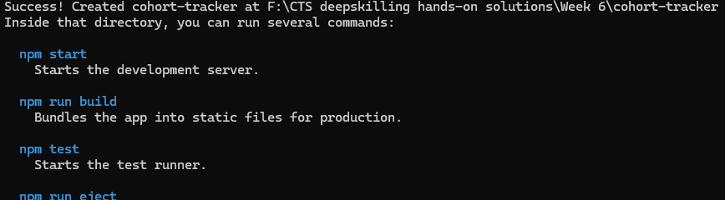after all packages are installed we get this success message.

3. Now we open the project folder in Visual Studio Code

4. In src folder we create a new folder called ‘components’, inside which we create CohortTracker.js

import React from 'react';

import styles from '../Stylesheet/mystyle.module.css';

const cohorts = [

  {

    id: "INTADMDF10 - Java FSD",

    startedOn: "22-Feb-2022",

    currentStatus: "Scheduled",

    coach: "Sabarish",

    trainer: "Balaji",

  },

  {

    id: "ADM21JF014 - .Net FSD",

    startedOn: "10-Sep-2021",

    currentStatus: "Ongoing",

    coach: "Akbar",

    trainer: "Sakshi",

  },

  {

    id: "INTADMDF01 - Python FSD",

    startedOn: "12-Jan-2023",

    currentStatus: "Completed",

    coach: "Sumithra",

    trainer: "Nisanth",

  },

  {

    id: "ADM21JF015 - React FSD",

    startedOn: "15-Mar-2023",

    currentStatus: "Ongoing",

    coach: "Finoshiya",

    trainer: "Thirksha",

  },

  {

    id: "INTADMDF11 - Angular FSD",

    startedOn: "05-Apr-2024",

    currentStatus: "Scheduled",

    coach: "Sathya",

    trainer: "Anita",

  },

];

function CohortTracker() {

  return (

    <div className={styles.gridContainer}>

      {cohorts.map((cohort, idx) => (

        <div key={idx} className={styles.cohortCard}>

          <div>

            <span

              className={

                cohort.currentStatus === "Ongoing"

                  ? styles.ongoingTitle

                  : styles.otherTitle

              }

            >

              {cohort.id}

            </span>

          </div>

          <div><strong>Started On</strong><br /><span>{cohort.startedOn}</span></div>

          <div>

            <strong>Current Status</strong><br /><span>{cohort.currentStatus}</span>

          </div>

          <div>

            <strong>Coach</strong><br /><span>{cohort.coach}</span>

          </div>

          <div>

            <strong>Trainer</strong><br /><span>{cohort.trainer}</span>

          </div>

        </div>

      ))}

    </div>

  );

}

export default CohortTracker;

5. In src folder we create a new folder called ‘Stylesheet’, inside which we create a CSS module “mystyle.module.css” we use a CSS module for component level styling

.gridContainer {

  display: grid;

  grid-template-columns: repeat(3, 1fr);

  gap: 2rem;

  justify-items: center;

  align-items: center;

  margin: 3rem auto;

  max-width: 1200px;

}

.cohortCard {

  border: 1px solid #ccc;

  border-radius: 10px;

  padding: 1.5rem;

  min-width: 230px;

  max-width: 260px;

  background: #fff;

  font-family: Arial, sans-serif;

  box-shadow: 2px 4px 10px rgba(0,0,0,0.07);

}

.ongoingTitle {

  color: #2e7d32;

  font-weight: bold;

  font-size: 1.1rem;

}

.otherTitle {

  color: #1a237e;

  font-weight: bold;

  font-size: 1.1rem;

}

in this CSS module we have added the required styling that was mentioned in the hands-on document different color for ongoing cohorts and cohorts, We have applied this style to the dummy cohorts that was created by mimicking card details from the output screenshot in the hands-on document

6. Now we modify the App.js to import the component and run the application

import React from 'react';

import CohortTracker from './components/CohortTracker';

function App() {

  return (

    <div className="App">

      <CohortTracker />

    </div>

  );

}

export default App;

**OUTPUT(Console):**

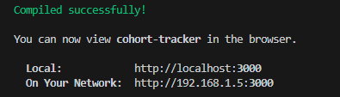

**OUTPUT(Browser):**

